Worldwide CBDC Use Cases

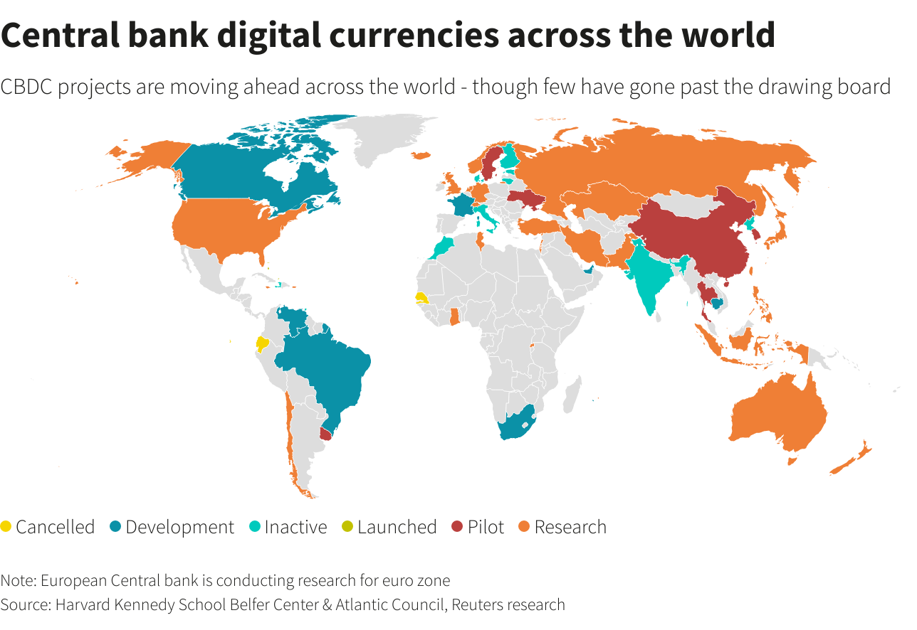

# Bahamas CBDC

**Implementation date: October 2020**

The Bahamas Central Bank implemented its own CBDC called “Sand Dollar”. Sand Dollar is pegged to the Bahamas Dollar, which is, in turn, pegged to the U.S. dollar. So, it can be considered as a pilot release of U.S. dollar by proxy. Sand dollar is domestic, so it cannot be held non-domestically. It can be used for the domestic wholesale and retail transaction.

The digital currency ecosystem supports digital payments, and composed of Authorized Financial Institutions (AFI) that include money transmitter businesses, payment service providers, and commercial banks. AFI provides services to the customers such as KYC/AML checks, wallet services, and custodial services for the sand dollar.

Bahamas digital wallets are designed to function in three tiers: the lowest tier limits the amount of sand dollar and does not require KYC/AML requirements. While the two other tiers have a risk based approach to KYC. However, higher amounts are taken into custody of the appropriate AFI. A multi-factor authentication secures the wallet. But the protection against SIM-swapping is still unknown.

Also, a digital id solution was created in parallel with the sand dollar.

Technically, NZIA was the Bahamas’ solution provider. Its novel consists of NZIA CortexDLT – a blockchain – at its foundation, hardware nodes running the platform, and a hybrid wireless network at the top that allows the mobile devices connection. Loss of power is a crucial feature in Bahamas. In this case, the wallet is synchronized eventually when the connection returns again.

# China

The People’s Bank of China (PBOC) aims to become the first major central bank that issues CBDC. Digital Yuan (PBOC CBDC) is designed to replace cash in circulation and not to replace the long-term deposited money in bank accounts. PBOC is trying, for future, to internationalize the yuan and reduce dependence on the dollar-dominated global banking system.

In September 2020, PBOC conducted internal trials of the digital currency electronic payment (DC/EP) – a two-tier Research and Development (R&D) and pilot program that may involve several payment products – in three cities: Shenzhen, Suzhou and Chengdu, including tests on paying goods and food delivery, and currently rolling it out on major e-commerce platforms within the country. However, the estimated launch timeline remains unrevealed.

The development of DC/EP is not completely along the same path as the so-called mainstream central bank digital currency (CBDC), and it's not a branch under that CBDC umbrella.

Digital Yuan working process is divided into two parts: distribution of digital Yuan and usage by digital yuan holders.

Distribution of digital yuan will be via a two-tier system. PBOC makes up the first tier and is in charge of building stable financial infrastructure and supervising the whole program. In the first tier, PBOC delivers digital yuan to the commercial banks. Each bank should deposit the same amount of their reserves with the PBOC as the digital yuan they distribute. Both the central bank and commercial bank distributors will keep databases tracking the flows of digital yuan from user to user. The second tier is composed from commercial banks, telecom operators and third-party payment paltforms. In this tier, commercial banks provide consumers with the digital currency services that allow them to get this currency such as exchange of coins and cash.

PBOC is unclear regarding the user’s usage of digital yuan. DC/EP technological solution could be account-based e-wallets. People can perform payments through QR codes, prepaid cards, or NFC technology. Most of the mobile payments in China rely on QR codes scanned by the merchant (Alipay, WeChat, etc.). Commercial banks could add these functionalities to their applications and the merchants’ applications dedicate section for digital yuan. Another possibility is to build mobile wallet for smartphone devices.

The People’s Bank of China suggested that its CBDC could function with smart contracts, but would not run on contracts that provide functionality beyond that of “basic monetary requirements”. This is due to concerns that it may add additional value to the CBDC and “downgrade” this CBDC into some kind of security, consequently reducing its stability and usability, and adversely affecting the internationalization of the Renminbi (RMB).

Technically, CBDC would be built on the following “one coin, two repositories, and three centers​" approach. Specifically, there are several elements that need to be considered:

* "One coin” refers to the Chinese CBDC itself: an encrypted digital string representing a specific amount guaranteed and signed by the PBOC.
* “Two repositories” refers to the central bank's issuance database and the commercial bank's database, as well as the digital currency wallets used by individuals or organizations.
* “Three centers"​refers to authentication, registration, and big data analysis centers. An overview of these centers are as follows:
  + Authentication center: PBOC would implement centralized management of financial institutions and end-user identity information, which are the basic component of system security and an important module of the controllable anonymity design. However, in the early stages of the system, the PBOC may only authenticate and manage the identity of financial institutions. In the future, authentication support for end-users may be built based on technologies such as IBC (identification-based cryptography).
  + Registration center: ​Record the identity of each unit of China’s CBDC and corresponding users, and complete the registration of China’s CBDC for the following functions: issuance, transfer and redemption.
  + Big data analysis center: ​Serve​ ​several functions such as preventing  
    anti-money laundering, analyzing payment behavior analysis, monitoring real-time regulatory indicators, etc.

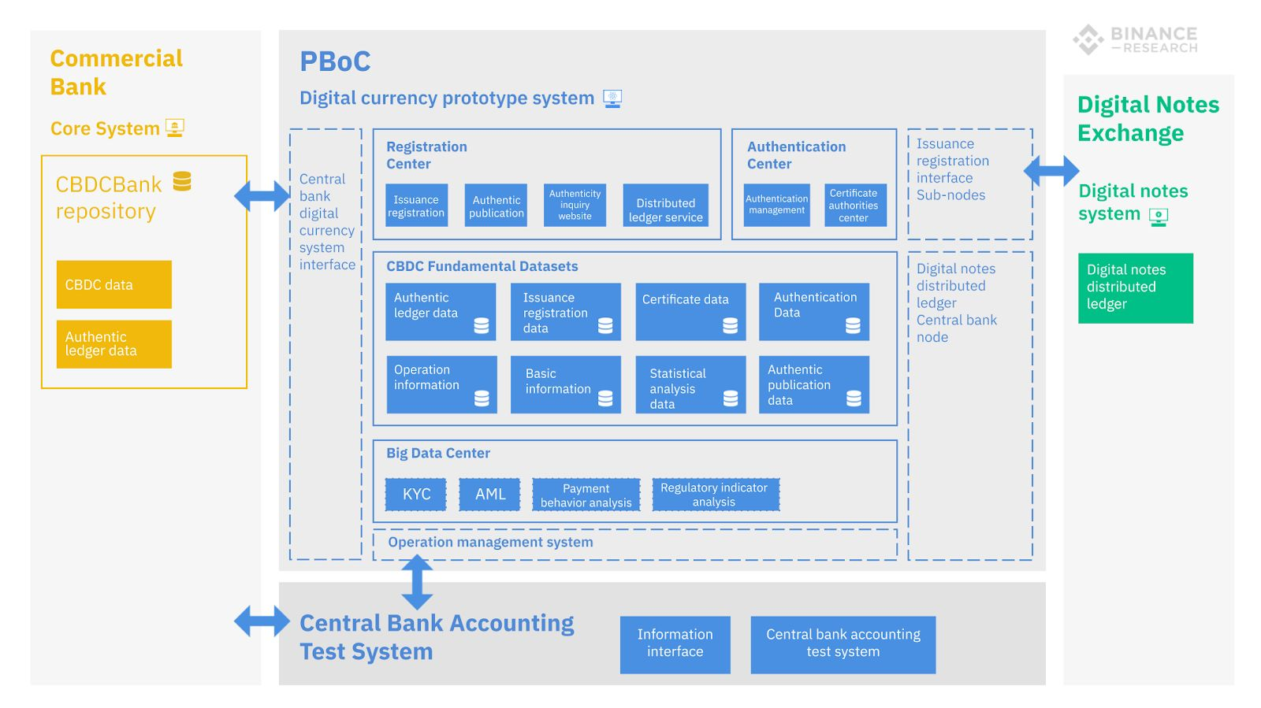

Figure 3 One, Two, Three approach schema

In brief, the China’s digital currency has a domestic focus and international use is not the immediate priority. Nevertheless, the PBOC joined central banks from Thailand, United Arab Emirates and Hong Kong to [explore a digital currency cross-border payment project together](https://www.cnbc.com/2021/02/24/chinas-pboc-joins-cross-border-digital-currency-project.html).

# Sweden

Sweden’s Riskbank has launched the third testing phase of E-Krona – Sweden’s CBDC – recently. Sweden’s project is assessed by a case study: Riskbank is consulted by Accenture and uses R3’s Corda platform.

E-krona will simulate the daily bank activities such as payments, deposits, and withdrawals from digital wallets.

Riskbank claimed that DLT tokens used for CBDC do not have great ability to provide cash-like features than an account-based. It considers that cash features to be a lack of traceability and the ability to operate when offline. Moreover, if the tokens have the ability to work offline, it will fail to reconcile once the device return online again to prevent double spending. On the other hand, the account-based has ledger held by a third party which imply a certain level of traceability. Another issue is when the customer exceeds a certain funding limit; he should comply with AML procedures, which fails in offline CBDC. Hence, the two features are not applied in both account-based and token-based CBDC.

Regarding the offline CBDC functionality, Sweden’s Riskbank claimed that there are existing offline solutions allowed on payment cards. There exist solutions that limit the number of times a token can be moved before its reconciliation to the ledger. Visa also reported a solution that require the payer to use a device with secure enclave, and an intermediary or wallet provider to allocate funds to a mobile phone for offline use.

The Sweden’s proposed outcome is value-based, closed system with a two-tiered architecture with a global notary (consensus) node as follows:

1. First tier: consists of three different node types: the Riskbank node that issues kronor (the token) to Participant (banks) and a Notary node confirming transactions.
2. Second tier: describes the distribution of kronor to end-users.

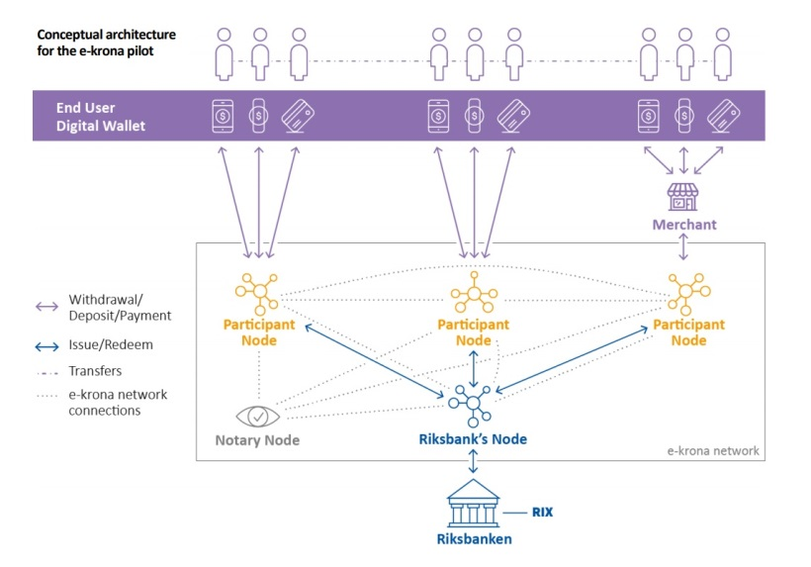

To become a node in the network, the operating entity must have indirect access to the central bank operated settlement system, RIX. As such access would be restricted to existing banks. These banks are expected to provide liquidity by reacting to consumer demand and exchanging their RIX balances (i.e., central bank money A) into Kronor-token (i.e., central bank money B). This consumer demand will have to outweigh the commercial banks’ costs of increasing their central bank money balances.

After activating a user wallet with a Network Participant, end-users shall be able to use kronor for P2P and P2C transactions in an inclusive, 24/7 available manner with offline functionality.

Notary nodes fulfill the role of miners in Nakatomo consensus-based blockchains. Notaries thus avoid double-spending and create finality for transactions. While Corda’s original whitepaper states that notaries “are expected to be composed of multiple, mutually distrusting parties”, there are simpler options – such as having only one notary node i.e., which is the case in this prototype.

The case study shines light on the role and relevance of technology providers and consultants. Certain technology providers, R3 in particular, appear to be dominating the provision of distributed ledger technology frameworks for CBDCs. Sweden’s e-krona seems to be the “generic R3 package”. The role of consultancies such as Accenture can be understood as “translating” between the functional expectations and the technical implementation.

Generally, the design elements displayed in the below table are considered in the typical “CBDC wish list”.

Table 1 E-Krona design choices in regards to common CBDC design elements

|  |  |  |
| --- | --- | --- |
| Design Element | Description | E-KRONA |
| Records of transfers and holdings | Value-based vs account-based | Value-based |
| Programmability | Eligible scope for smart contracts | Yes |
| Transfer mechanism | Peer to peer vs use of intermediaries | Peer to Peer (TBD) |
| Level of transparency | Degree of anonymity for CBDC payments | TBD |
| Availability | 24/7/365 vs restricted hours | 24/7/365 |
| Convertibility | Restrictions of converting central bank or commercial bank money: no/ restricted/ unrestricted | TBD |
| Interest-bearing functionality | CBDC dedicated/general/ no interest rate | TBD |
| Offline functionality | Yes/No | Yes |
| Integration with existing platforms (via APIs) | Yes/No | Yes |

When assessing the e-krona within this framework, it becomes evident that various design specifications have not yet been made. As such, the current e-krona prototype is exciting, potentially even representative of the most common development status, but most likely neither pioneering, nor the most advanced CBDC set-up.

# Republic of Marshall Islands

Marshall Islands launches its central bank digital currency – Marshallese sovereign (SOV) – on Algorand blockchain protocol, while SFB Technologies is the company that develops SOV’s blockchain infrastructure. Algorand is an open-source blockchain protocol provider, permissionless and with proof-of-stake protocol. It also allows the development of scalable blockchain solutions for real use cases. So, the Algorand protocol will be implemented to provide the SOV initiative with speed, scalability, and security. The protocol also provides the required compliance controls such as identity management and the compliance platform.

“Marshall Island’s vision is for global participation and inclusion in an open financial system by harnessing the benefits of blockchain technology. It is consistent with a truly global and decentralized society. We also believe it made possible with our technology. We are proud to support the country on its revolutionary journey towards the adoption of digital currency, “said Silvio Micali, founder of Algorand.

The island nation aims to reduce its dependence on the US dollar, which is currently the national currency. Algorand clarified that the SOV would circulate alongside the US dollar. The SOV supply will algorithmically fix at 4% growth per year to prevent inflation.

# Ukraine

# Uruguay

**Completed one pilot test**